# Build a table containing the exposure times of these six images

The table was built by using Windows’ properties tab.

|  |  |
| --- | --- |
| name | exposure_time |
| office_1.jpg | 1/30 |
| office_2.jpg | 1/10 |
| office_3.jpg | 1/3 |
| office_4.jpg | 0.62 |
| office_5.jpg | 1.3 |
| office_6.jpg | 4 |

# obtain the camera’s response curves

The camera response curves were obtained from HDRShop with 2000 iterations and were saved under the file $curve.m$.

# Create an HDR image from the sequence

The generated image was saved under the file $HDRShop result.tif$.

# create an HDR image from the provided six LDR images

The HDR image was created by iterating upon each pixel of each image, discarding 0 and 255 values, calculating the irradiance with the curve from step 2 and getting the average. This image is not visualizable on regular image displayers due to it being a floating-point image with no normalization.

# Implement the global version of Reinhard’s photographic tone mapping operator

To implement the global operator, first we need to get a luminance image which can be easily calculated by iterating upon the pixels of the HDR image. Then, calculate the global operator itself and scale the HDR image pixels by it.

The result was saved under the PNG format with 16 bits precision.

Figure 1 - LDR tone mapped image

The image appears to be too dark. Applying a gamma correction does make it lighter.

Figure 2 - Gamma corrected LDR image

Still, there is a general red bias and desaturation on the image, which is more evident when we compare it to the HDRShop version.

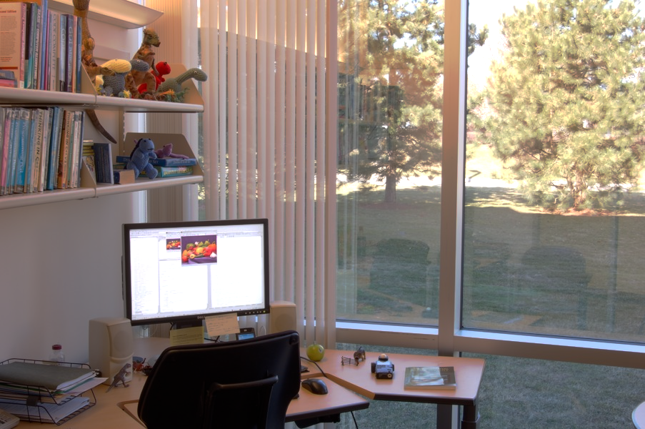

Figure 3 - HDRShop HDR image

This may be happening due to HDR using a different tone mapping algorithm for generating the HDR image, or a bias in its calibration curve.

Opening the 32 bit float HDR image directly can be done with Photoshop, where we can apply a local tone mapping.

Figure 4 - Photoshop tone mapped image

We can see that this red tint still appears, so it was not caused by the global tone mapping implementation. Perhaps it is the calibration curve created by HDRShop that is producing this tone.